Star Topology

What Is Star Topology?
# Source: Chatgpt (GPT‑5 Mini) at [12/18/2025]
A star topology is a network layout where all devices are connected to a central device such as a switch, hub, or router. It is the most commonly used topology in modern LANs (Local Area Networks).

🧠 Simple Definition:
# Source: Chatgpt (GPT‑5 Mini) at [12/18/2025]
In a star topology, each device (node) has a dedicated point-to-point connection to a central device, which controls communication.

📷 Visual Representation:
# Source: Chatgpt (GPT‑5 Mini) at [12/18/2025]
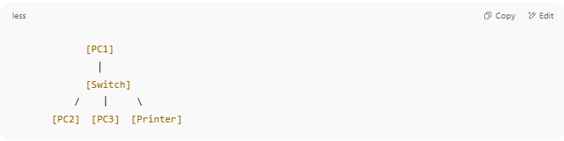
[PC1]
│
[Switch]
/ | \
[PC2] [PC3] [Printer]

Each device connects only to the central switch, not directly to each other.

🔁 How It Works
# Source: Chatgpt (GPT‑5 Mini) at [12/18/2025]
- When a device (e.g., PC1) sends data:
  - It goes to the central switch.
  - The switch then forwards it to the correct destination (e.g., PC3).
- The switch uses MAC addresses to direct traffic (in Layer 2 networks).

✅ Advantages
# Source: Chatgpt (GPT‑5 Mini) at [12/18/2025]
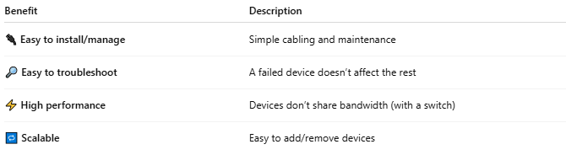

Benefit | Description
🔌 Easy to install/manage | Simple cabling and maintenance
🔎 Easy to troubleshoot | A failed device doesn’t affect the rest
⚡ High performance | Devices don’t share bandwidth (with a switch)
🔁 Scalable | Easy to add/remove devices

❌ Disadvantages
# Source: Chatgpt (GPT‑5 Mini) at [12/18/2025]
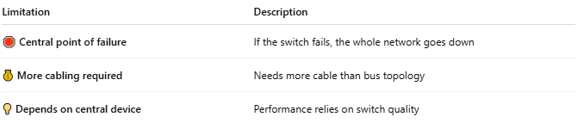

Limitation | Description
🛑 Central point of failure | If the switch fails, the whole network goes down
💰 More cabling required | Needs more cable than bus topology
💡 Depends on central device | Performance relies on switch quality

🛠️ Components in Star Topology
# Source: Chatgpt (GPT‑5 Mini) at [12/18/2025]
- Central device (Switch, Hub, or Router)
- Cables (usually Ethernet)
- End devices (PCs, printers, IP phones, etc.)

📍 Common Use Cases
# Source: Chatgpt (GPT‑5 Mini) at [12/18/2025]
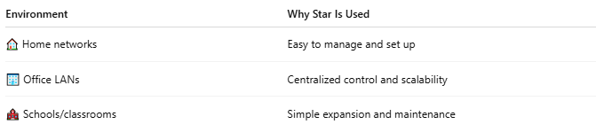

Environment | Why Star Is Used
🏠 Home networks | Easy to manage and set up
🏢 Office LANs | Centralized control and scalability
🏫 Schools/classrooms | Simple expansion and maintenance

🧾 Comparison: Star vs Bus
# Source: Chatgpt (GPT‑5 Mini) at [12/18/2025]
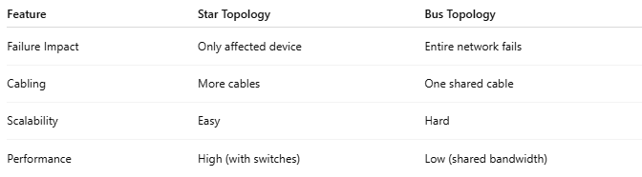

Feature | Star Topology | Bus Topology
Failure Impact | Only affected device | Entire network fails
Cabling | More cables | One shared cable
Scalability | Easy | Hard
Performance | High (with switches) | Low (shared bandwidth)

✅ Summary
# Source: Chatgpt (GPT‑5 Mini) at [12/18/2025]
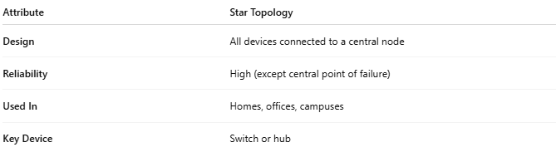

Attribute | Star Topology
Design | All devices connected to a central node
Reliability | High (except central point of failure)
Used In | Homes, offices, campuses
Key Device | Switch or hub

